SESSION – 8 (Kashish kumbhare html/css)

Q.1) Create a Flipkart-style product card in HTML and CSS, then use a meta viewport tag to ensure it scales correctly on mobile devices.
Ans).
<!DOCTYPE html>
<html lang="en">
<head>
<meta charset="UTF-8">
<!-- Makes the webpage responsive on mobile devices -->
<meta name="viewport" content="width=device-width, initial-scale=1.0">
<title>Flipkart Product Card</title>
<style>
body {
font-family: Arial, sans-serif;
background-color: #f1f3f6;
margin: 0;
padding: 20px;
}
.product-card {
width: 90%;
max-width: 300px;
margin: auto;
background-color: white;
border-radius: 10px;
padding: 15px;
text-align: center;
box-shadow: 0 2px 8px rgba(0, 0, 0, 0.2);
}
.product-card img {
width: 100%;
height: auto;
border-radius: 5px;
}
.product-card h2 {
font-size: 22px;
margin: 10px 0;
}
.price {
color: green;
font-size: 20px;
font-weight: bold;
}
.product-card button {
background-color: #ff9f00;
color: white;
border: none;
padding: 10px 20px;
margin-top: 10px;
font-size: 16px;
border-radius: 5px;
cursor: pointer;
}
.product-card button:hover {
background-color: #fb8c00;
}
</style>
</head>
<body>
<div class="product-card">
<img src="/Headphone.avif" alt="Product Image">
<h2>Wireless Headphones</h2>
<p>High-quality sound with comfortable design.</p>
<p class="price">₹1,999</p>
<button>Add to Cart</button>
</div>
</body>
</html>

Result:
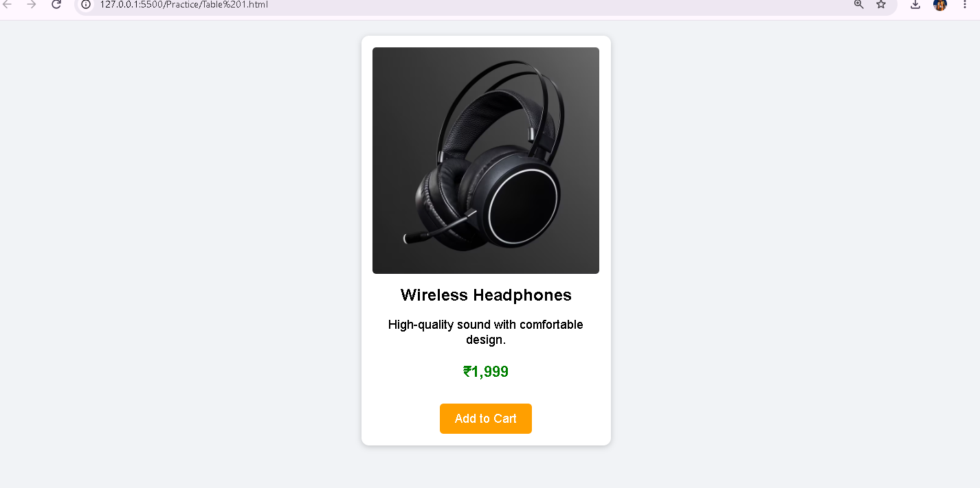

Q.2) Add media queries to your product card so that when the screen width is 600px or less, the card layout switches from horizontal (image and details side by side) to vertical (image on top, details below).
Ans).
<!DOCTYPE html>
<html lang="en">
<head>
<meta charset="UTF-8">
<!-- Makes the page responsive on mobile devices -->
<meta name="viewport" content="width=device-width, initial-scale=1.0">
<title>Responsive Flipkart Product Card</title>
<style>
body {
font-family: Arial, sans-serif;
background-color: #f1f3f6;
margin: 0;
padding: 20px;
}
/* Product Card - Horizontal Layout */
.product-card {
display: flex;
align-items: center;
gap: 20px;
max-width: 700px;
margin: auto;
background-color: white;
padding: 20px;
border-radius: 10px;
box-shadow: 0 2px 8px rgba(0, 0, 0, 0.2);
}
/* Product Image */
.product-card img {
width: 250px;
height: 200px;
object-fit: cover;
border-radius: 8px;
}
/* Product Details */
.product-details {
flex: 1;
}
.product-details h2 {
margin-top: 0;
}
.price {
color: green;
font-size: 22px;
font-weight: bold;
}
button {
background-color: #ff9f00;
color: white;
border: none;
padding: 10px 20px;
font-size: 16px;
border-radius: 5px;
cursor: pointer;
}
/*Mobile Layout */
@media (max-width: 600px) {
.product-card {
flex-direction: column;
text-align: center;
}
.product-card img {
width: 100%;
height: auto;
}
}
</style>
</head>
<body>
<div class="product-card">
<img src="/Headphone.avif"
alt="Wireless Headphones">
<div class="product-details">
<h2>Wireless Headphones</h2>
<p>
Enjoy high-quality sound with a comfortable and stylish design.
</p>
<p class="price">₹1,999</p>
<button>Add to Cart</button>
</div>
</div>
</body>
</html>

Result:
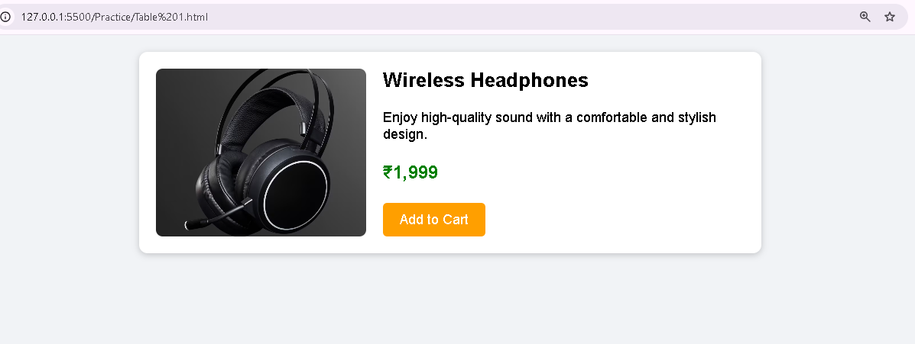

Q.3) Set up three breakpoints (600px, 900px, 1200px) for your product card and change the card's font size and padding at each breakpoint to improve readability on different devices.<br><br><em><strong>Hint:</strong> Use @media only screen and (max-width: ...) in your CSS for each breakpoint.</em>
Ans).
<!DOCTYPE html>
<html lang="en">
<head>
<meta charset="UTF-8">
<meta name="viewport" content="width=device-width, initial-scale=1.0">
<title>Responsive Product Card</title>
<style>
body {
font-family: Arial, sans-serif;
background-color: #f1f3f6;
margin: 0;
padding: 20px;
}
/* Default Product Card */
.product-card {
display: flex;
align-items: center;
gap: 20px;
max-width: 700px;
margin: auto;
background-color: white;
padding: 30px;
font-size: 20px;
border-radius: 10px;
box-shadow: 0 2px 8px rgba(0, 0, 0, 0.2);
}
.product-card img {
width: 250px;
height: 200px;
object-fit: cover;
border-radius: 8px;
}
.product-details {
flex: 1;
}

.price {
color: green;
font-weight: bold;
}
button {
background-color: #ff9f00;
color: white;
border: none;
padding: 10px 20px;
font-size: 16px;
border-radius: 5px;
cursor: pointer;
}
/* Breakpoint: 1200px or less */
@media only screen and (max-width: 1200px) {
.product-card {
font-size: 18px;
padding: 25px;
}
}
/* Breakpoint: 900px or less */
@media only screen and (max-width: 900px) {
.product-card {
font-size: 16px;
padding: 20px;
}
}
/* Breakpoint: 600px or less */
@media only screen and (max-width: 600px) {
.product-card {
flex-direction: column;
text-align: center;
font-size: 14px;
padding: 15px;
}
.product-card img {
width: 100%;
height: auto;
}
}
</style>
</head>
<body>
<div class="product-card">
<img src="/Headphone.avif"
alt="Wireless Headphones">

<div class="product-details">
<h2>Wireless Headphones</h2>
<p>
Enjoy high-quality sound with a comfortable and stylish design.
</p>
<p class="price">₹1,999</p>
<button>Add to Cart</button>
</div>
</div>
</body>
</html>

Result:
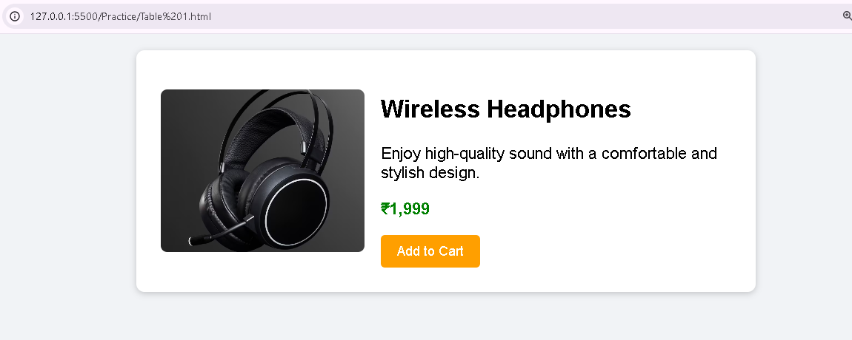

Q.4) Test your responsive product card by resizing your browser window and taking screenshots at mobile, tablet, and desktop widths; submit the screenshots along with a short note on what changes at each size.
Ans)
<head>
<meta name="viewport" content="width=device-width, initial-scale=1.0">
<style>
/* Your normal CSS */
.product-card {
display: flex;
padding: 30px;
font-size: 20px;
}
/* Put the breakpoints here */
@media only screen and (max-width: 1200px) {
.product-card {
padding: 25px;
font-size: 18px;
}
}
@media only screen and (max-width: 900px) {
.product-card {
padding: 20px;
font-size: 16px;
}
}
@media only screen and (max-width: 600px) {
.product-card {
flex-direction: column;
padding: 15px;
font-size: 14px;
}
}
</style>
</head>
